Xiaoming sharing | sigmstar SSD201/SSD202 LCD screen configuration operation instructions for RGB sharing

Kai MingxianPosted at 2021-01-04 14:43:41884 Favorite 5
Article tags: RGB screen SSD201 SSD202
copyright

The configuration of SSD20X platform LCD screen mainly involves two structures: MI_PANEL_ParamConfig_t, MI_PANEL_MipiDsiConfig_t and they are defined in: project/release/include/mi_panel_datatype.h.

RGB screen
υ Configure PAD to TTL mode: # vi infinity2m-ssc011a-s01a-padmux-display.dtsi
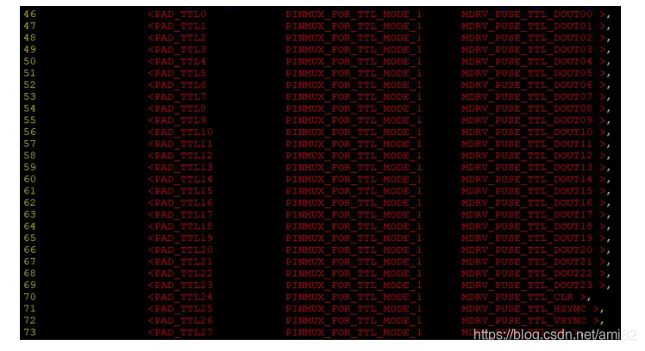
υ Obtain the timing table from the screen’s data sheet:
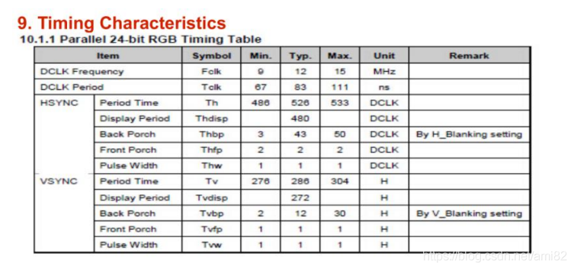
υ Modify the screen parameters to download test/JpegPlayer.rar and unzip it, find SAT070CP50_1024x600.h, in On this basis, modify the corresponding data according to the actual parameters of the screen:
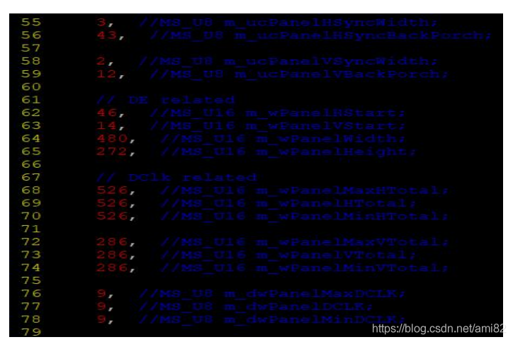
pay attention to the values ​​of the following variables:
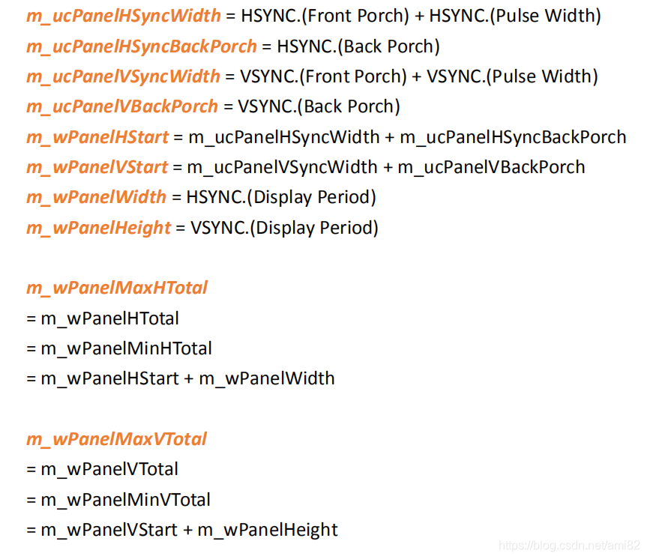
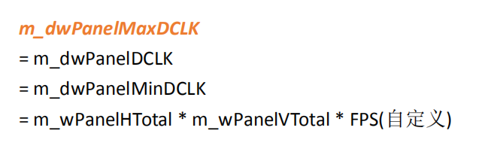
(DCLK Frequency).min <= m_dwPanelMaxDCLK <= (DCLK Frequency).max
υ Modify the value of swap
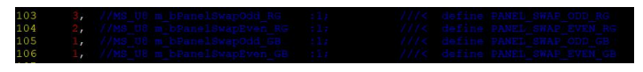
By default, the corresponding relationship between each TTL pin and RGB is as follows:
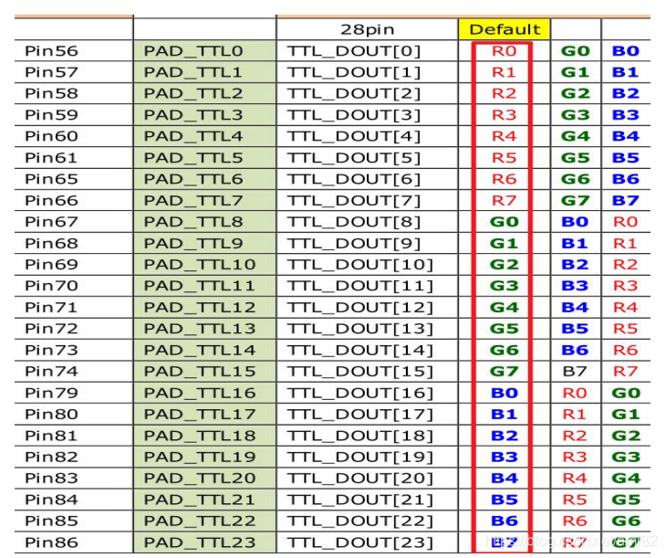
If the actual connection is not the default connection, you need to modify the swap value. The following 4 values ​​need attention:
m_bPanelSwapOdd_RG, when its value is 0 or 3, it corresponds to R; when its value is 1, it corresponds to B; when its value is 2, it corresponds to G;
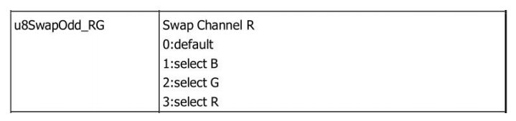
m_bPanelSwapEven_RG, when its value is 0 or 2, it corresponds to G; When it is 1, it corresponds to B; when it is 3, it corresponds to R;
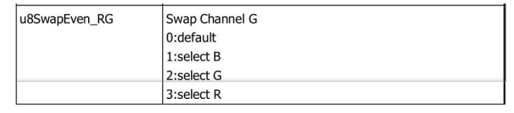
m_bPanelSwapOdd_GB, when its value is 0 or 1, it corresponds to B; when its value is 1, it corresponds to B; when its value is 2, it corresponds to G
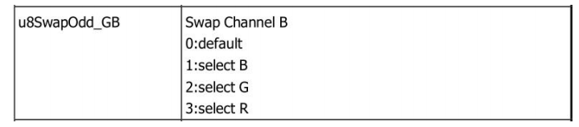
; When the value is 1, the high and low bits of RGB are reversed;
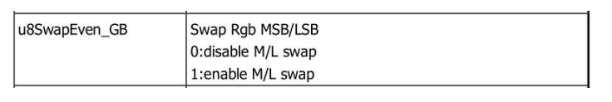
when the high and low bits are not reversed, the corresponding relationship between the pins is as follows:
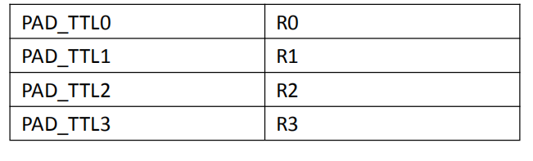
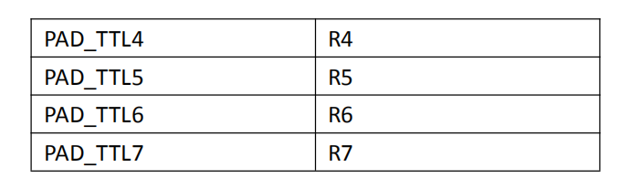
After the high and low bits are reversed, the corresponding relationship between the pins becomes:
